MEX-Michoacan-Nayarit-Female Figure

Nayarit female figure for auction at no reserve. This ancient lady was crafted by the Nayarit Culture of Western Mexico. Nayarit was part of the Shaft Tomb Culture which included Nayarit, Colima, Jalisco, and Michoacan. This large female figure has a headdress or hat, ear spools, a necklace, and a skirt which is still packed with ancient dirt from when it was excavated. She is holding an offering on her shoulder. The arm to the shoulder was repaired at some point, but isn't noticeable. SHe has a great red slip. She stands on her own and displays very, very nicely.

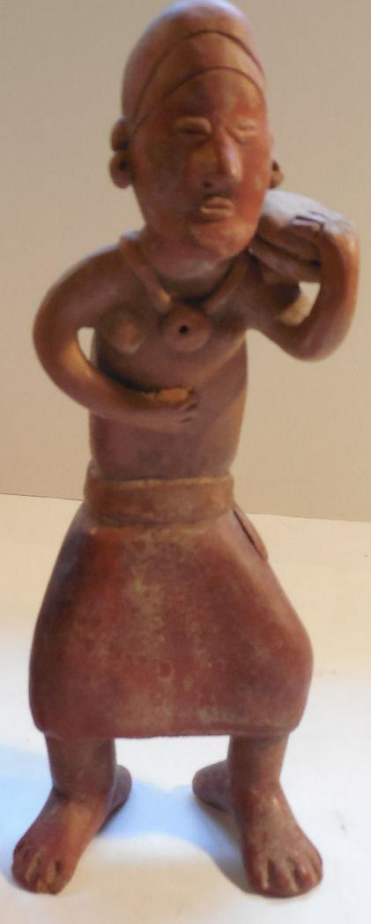

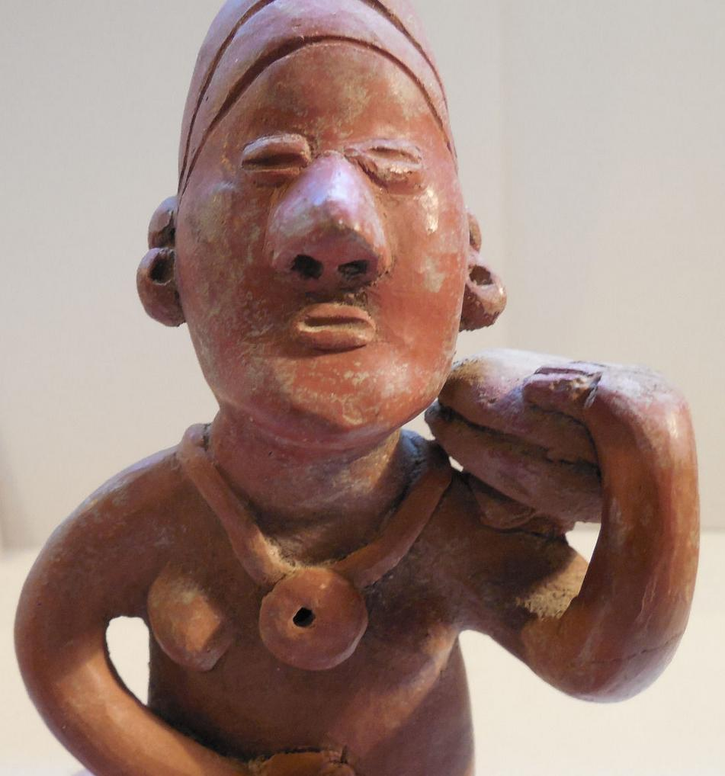

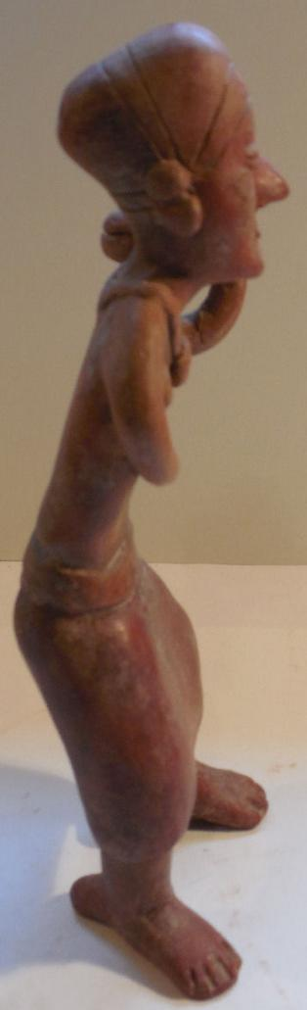

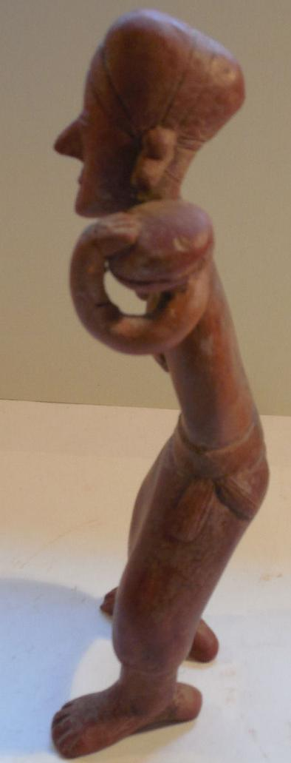

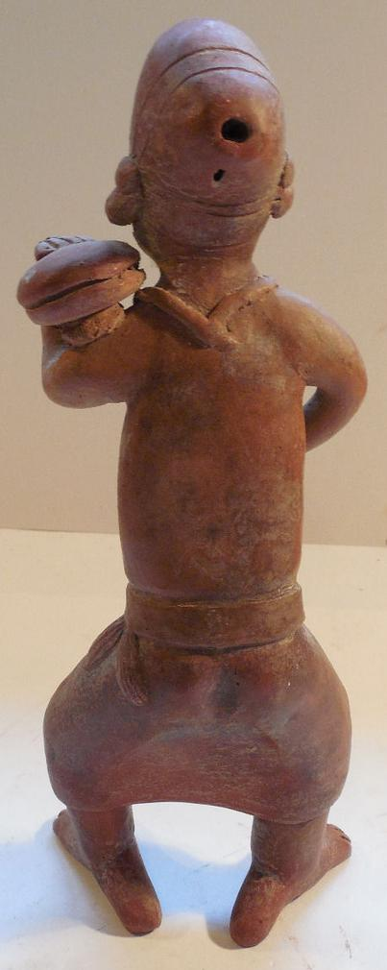

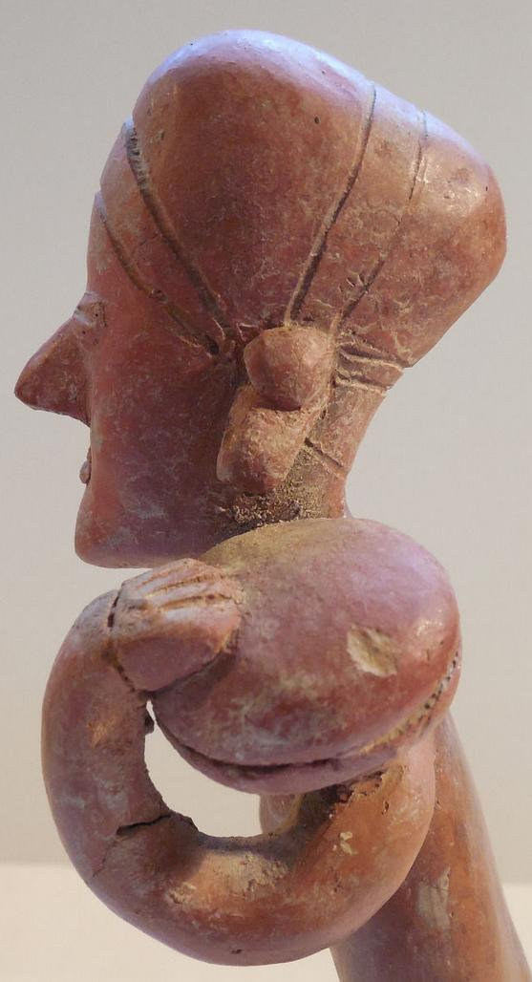

# Order details

## Sales order

Sold by [bobski117](http://myworld.ebay.com/bobski117) ( [2813](http://feedback.ebay.com/ws/eBayISAPI.dll?ViewFeedback&userid=bobski117) )

### Delivery package 1 of 1

Estimated delivery Thursday, Dec 31, 2015 - Tuesday, Jan 5, 2016

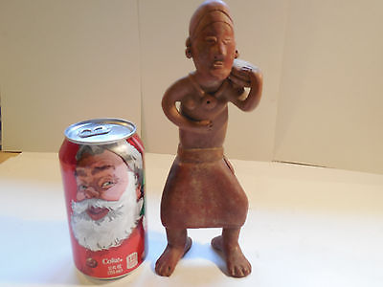

#### [Large Nayarit Woman Shaft Tomb Pre-Columbian Ancient Artifact Colima Aztec Mayan](http://www.ebay.com/itm/121846040301)

|  |  |
| --- | --- |
| Item price | $177.50 |
| Quantity | 1 |
| Item number | 121846040301 |
| Shipping service | USPS Priority Mail |